**Assignment – 1**

|  |  |
| --- | --- |
| Student Name/ID Number: | Agung Yuda Pratama/BDSE-0922-076 |
| Unit Number and Title: | Develop Project Proposal |
| Academic Year: | 2022 |
| Unit Assessor: | Arvinder Kaur |
| Project Title: | Develop Enterprise Applications |
| Issue Date: |  |
| Submission Date: |  |
| Internal Verifier Name: |  |
| Date: | June 2023 |

|  |
| --- |
| **Learner declaration** |
|  |
| I certify that the work submitted for this assignment is my own and that research sources are fully acknowledged.  Student signature: Date: June 2023 |

**MEALS ON WHEELS**

**Assignment 1 - Project Proposal**



**AGUNG YUDA PRATAMA (BDSE-0922-076)**

**SOFTWARE ENGINEERING**

**LITHAN EDUCLAAS**

**(2023)**

1. **Project Introduction**
   1. **Project Background**

The "Meals On Wheels" project aims to meet the needs of eligible adults who cannot cook for themselves due to age, illness, or disability. MerryMeal, a nonprofit, has teamed with food service companies nationwide to deliver hot lunches to members' homes efficiently. In addition, frozen meals are offered to members on weekends and outside of a 10-kilometer range from contracted cooks. As a full-stack web developer at Unity One Solutions, we have been assigned to design and create a software solution for this project.

This is the list of users who will interact with the system :

* + 1. Members: Adults who meet the requirements and need meal services but cannot prepare food due to age, disease, or disability. They will communicate with the system to register, supply particular requirements, and access meal services.
    2. Caregivers: People in charge of caring for the members and aiding them in running their food services. Caregivers will communicate with the system to help members register, update information, and organize food deliveries.
    3. Partners: Food service providers and organizations partnered with Meals on Wheels to support meal delivery operations. Partners will interact with the system to register, provide their details, and collaborate in meal planning, preparation, and delivery.
    4. Volunteers: Individuals who volunteer their time and services to assist Meals on Wheels in various meal delivery and serve the meal. Volunteers will interact with the system to register, provide their information, and participate in delivering meals or cooking meals for members.
    5. Donors/Supporters: Individuals or organizations interested in supporting the Meals on Wheels project cause through financial contributions. Donors and supporters will interact with the system to make donations, view fundraising efforts, and see the members.
    6. Administrators: Staff responsible for managing and overseeing the operations of Meals on Wheels. Administrators will have privileged access to the system to manage user accounts, monitor meal deliveries, evaluate needs, generate reports, and ensure effective program management.
  1. **Pain Points**

A pain Point is a specific problem from the customer's perspective in the business. However, not all prospects will be aware of the pain point they are experiencing, which can make business with these individuals difficult. We effectively help your chances realize they have a problem and convince them that your product or service will help solve it.

Here are the four main types of pain points:

1. Financial Pain Points: Your prospects' money on their current supplier, solution, or products is too much, and they want to cut back.
2. Productivity Pain Points: Your prospects desire to be more productive with their time or feel they are wasting it with their present supplier, solution, or products.
3. Process Pain Points: Includes anything related to how your business interacts with customers, whether it is how you connect customers to the correct department, how you handle support tickets, or even how you handle internal communications.
4. Support Pain Points: A sound customer care system is essential for any company. According to studies, one out of every three clients may consider quitting your firm after one poor customer care experience out of every three clients may consider terminating your firm after one poor customer care experience. Customers may become irritated and leave your app or website if they need help to get the help they need due to frequent issues like slow response times and ignorance about the product.

The following provides an overview of the fundamental SWOT Analysis associated with Merry Meals.

**SWOT ANALYSIS**

SWOT analysis was first introduced by Albert S. Humphrey, who used this technique in the 1960s when he initiated a research project being undertaken at the Stanford Research Institute. Since then, SWOT analysis has slowly begun to be widely recognized by wide circles and is gradually being used by business people to use these analysis methods to grow and develop their respective companies. When analyzed together, a SWOT framework can paint a bigger picture of where you are and how to reach the next step.

SWOT analysis is a strategic planning method that considers and evaluates four main components, namely:

1. Strengths

The component in the first SWOT analysis is strengths, or we can interpret it as strength. From here, we can see how far the factors are the strengths of the business or project we are working on.

2. Weaknesses

The component in the second SWOT analysis is a weakness, or we can interpret it as a weakness. From here, we can see the factors that are weaknesses in the business or project we are working on.

3. Opportunities

The component in the third SWOT analysis is opportunities, or we can interpret them as opportunities. From here, we can see how far the factor has become opportunities in the business or project e are working on.

4. Threats

The component in the fourth SWOT analysis is opportunities or what we can interpret as threats. From here, we can see how far the factors threaten the business or project we are working on.

This is **SWOT Analysis** for **Meals on Wheels:**

1. **Strengths**
   * + 1. We are very concerned about consumer needs.
       2. We are very concerned about the nutritional content of the food that will be given to consumers.
       3. We can reach consumers who are more than 10 kilometers away.
       4. Because it is online-based, our services will save time.
       5. Our Application is suitable for the target market
       6. MerryMeal is a reputable charity with expertise in cooking and delivering meals to eligible needy adults.
2. **Weaknesses**
   * + 1. Because the distance between the driver and the kitchen is likely to be far, there is a possibility that the food will be delivered late.
       2. The service for Hot Meals is only available on weekdays, so members who require Hot Meals weekend meals may not be adequately supported.
       3. Members who live more than 10 kilometers from the kitchen may receive frozen meals, which could degrade the food's quality and freshness.
3. **Opportunities**
   * + 1. We are a Pioneer Organization online-based charity program.
       2. This app can offer a productive platform for registering and managing their information, simplifying operations for members, caregivers, partners, and volunteers.
       3. By offering a platform for donors to promote MerryMeal's cause, this app can aid fundraising efforts.
       4. There is no strict competition in the program that we make
       5. The government highly supports our program
4. **Threats**
   * + 1. The rapid development of technology is beyond our control
       2. Other charitable organizations offering similar services may pose a competitive threat to MerryMeal.
       3. The need for donors for this charity program will cause a deficit in money and supply.
   1. **Project Objectives**

1.3.1 Analyze Meals on Wheels business requirements: To pinpoint the precise requirements and difficulties Meals on Wheels encounters in successfully providing meals to its members, the project will conduct a complete analysis of its operations, procedures, and data kinds.

1.3.2 Develop an appropriate software solution: Create precise design plans and blueprints for software solutions based on the investigation. Creating a strong framework for development, includes specifying system architecture, user interface design, database structure, and other technical standards.

1.3.3 Implement a functional business application: The project includes the creation and implementation of a proper application that enables Meals on Wheels to manage a number of its operational aspects, including member and caregiver registration, partner and volunteer registration, fundraising, menu planning and preparation, meal delivery management, food safety management, need assessments, and a management information system for efficient management.

1.3.4 Evaluate application performance and identify improvements: The project team will assess how well the produced application performs compared to its design goals. Analysis of performance-influencing factors, identification of strengths and deficiencies, and suggestions for future growth and improvement are all included in the review.

* 1. **Project Goals**

Meals on Wheels aims to provide a hot lunch meal for eligible adults who are too old, have an illness, or have a disability, to maintain a healthy diet. Meals on Wheels is a charitable organization partnered with several food and donation service providers. A sitter manages food service, and riders will deliver food company. The company also accepts those who wish to volunteer as riders or partners to help with charity.

* 1. **Project Scope**

**System Overview -** The application will have the following functionality:

1. Members and Caregivers registration with their requirements

2. Partners and Volunteers registration with their details

3. Fundraising through Donors / Supporters

4. Menu Planning and Preparation

5. Meal Delivery Management of partners and riders

6. Food Safety Management

7. Reassessment of need evaluation, and,

8. Management Information System for effective management

1. **Project initiation** 
   1. **Project Stakeholder**
      1. Sponsor of Merry on Wheels application.
      2. Mr. David, Project Manager of Unity One Solution.
      3. Member of Merry Meals charity organization as a client.
      4. Merry Meals project team member.
   2. **Feasibility study**

Feasibility studies are conducted to assess the feasibility of successful software project implementation. This establishes the viability of the proposed project. Typically, this analysis is carried out following the collection of project requirements. It assesses a number of factors, including the software's direct and indirect advantages to the business, the viability and applicability of suggested software-related solutions, the capacity to achieve project deadlines, and the availability of sufficient resources. The cost of completing the project is also estimated, considering things like hardware, software license, development and testing, project management, and organizational effort. The study then makes an estimate of the price of system upkeep following development and deployment. Additionally, it evaluates the proposed system's legality and assures adherence to established standards.

* + 1. **Technical Feasibility**

This kind of feasibility study depends on the business's technical capabilities. A technical feasibility study can help a business determine whether its technical capabilities match the project's resource needs and can turn the idea into the best operating system. The technical feasibility study also includes evaluating the software, hardware, and other technical aspects announced during the project planning stage.

* + - 1. **Familiarity with the application**

Familiarity with the application refers to the knowledge and experience of the project stakeholders with the proposed software application, "Meals on Wheels." In this case, the stakeholders include the sponsor of the application, Mr. David (the project manager of Unity One Solution), Merry Meals charity organization members, and Merry Meals project team members. It is crucial to assess their familiarity with the application's specific requirements, functionalities, and objectives. This familiarity will contribute to effective communication, collaboration, and decision-making throughout the project.

**Familiarity with technology**

On the other hand, familiarity with technology relates to a stakeholder's knowledge and experience with the technical aspects of a software project. This includes their understanding of the project's specified hardware, software, and network requirements. Assessing a stakeholder's familiarity with the technology helps identify potential challenges or training needs in using the required technology effectively. This ensures that stakeholders have the necessary skills to work with the hardware, software, and network components involved in the project.

* + - 1. **Project Size**

The estimated project size is 20MB

* + - 1. **Hardware, Software, and Network requirement**

**This is the Technical Feasibility for Meals on Wheels**

1. Hardware Requirements

|  |  |  |  |
| --- | --- | --- | --- |
| **No** | **Hardware** | | |
| **Type** | **Server** | **Client** |
| 1 | Processor | Intel Xeon Silver 4210 2.2GHz Turbo 3.2GHz | Intel Core i3 |
| 2 | Memory | 32 GB | 8 GB |
| 3 | Hard Drive | 4 TB | 1 TB |
| 4 | SSD | 2TB NVMe Gen. 4 | Sata |
| 5 | Network | Gigabit Network | Gigabit Network |
| 6 | Monitor | Asus TUF VG328H1B 31.5" | Monitor 24” |
| 7 | PSU | Seasonic Prime Titanium TX-1000 - 1000W 80+ Titanium Certified | Standard PSU |
| 8 | Keyboard & Mouse | USB Mouse Keyboard | USB Mouse Keyboard |

1. Software Requirements

|  |  |  |
| --- | --- | --- |
| **No** | **Software** | **Functionality** |
| 1 | Windows 10 | Operating System |
| 2 | Bootstrap, CSS, React JS, Spring Boot | Web Creation |
| 3 | MySQL Workbench | Database Server |
| 4 | Apache Tomcat / Apache Maven | Web Server |
| 5 | Axure | Design |
| 6 | Google Chrome, Mozilla Firefox, Microsoft Edge | Web Browser |

1. Network Requirements

|  |  |  |
| --- | --- | --- |
| **No** | **Network Device** | **Functionality** |
| 1 | Switch | Cable connecting network from workstation |
| 2 | UTP Cable | Connecting Medium |
| 3 | RJ 45 Connector | Cable connecting network with LAN Card |

1. Contractors

|  |  |  |
| --- | --- | --- |
| **No** | **Schedule** | **Contractor** |
| 1 | June 15, 2023 - July 07, 2023 | Unity One Solution |

1. Skills & Human Resource

|  |  |  |
| --- | --- | --- |
| **No** | **Requirements** | **Skills** |
| 1 | UI/UX Designer | Axure |
| 2 | Web Developer | HTML, CSS, JavaScript, Bootstrap, React JS, Java, Spring Boot, Database, DBMS. |

* + 1. **Operational feasibility**

Operational feasibility is a crucial aspect of assessing the implementation of a proposed system to determine if it can be successfully executed and fulfill the project's objectives optimally. This analytical study aims to verify whether the project plan aligns with business requirements, effectively improves processes, reduces costs, and enhances organizational efficiency. It plays a vital role during the project development analysis stage by evaluating the extent to which the proposed system meets the requirements. By conducting an operational feasibility study, organizations can gain valuable insights into the feasibility and viability of implementing the project successfully.

|  |  |  |
| --- | --- | --- |
| **No** | **Requirements** | **Descriptions** |
| 1 | Performance | Can serve 750 requests at once. |
| 2 | Information | Five decimal precision information that is more accurate. |
| 3 | Economy | Costs incurred are relatively lower due to errors reporting can be minimized. |
| 4 | Control | System control is carried out by limiting user rights. Each Role has its access. |
| 5 | Efficiency | Because using a database can prevent duplicate data entry, saving more time. |
| 6 | Services | The level of satisfaction with services can be increased because the system presents information in a consistent format. |
| 7 | Operational Feasibility Value | It is a locally based system (for organizations only) with a Layout as standard as possible, so it has a value of 8.5. |

* + 1. **Economic feasibility**

Economic feasibility is a critical aspect of assessing the feasibility of a project, ensuring that the expected benefits outweigh the anticipated costs within an acceptable timeframe. Performing a Cost Benefit Analysis helps evaluate the economic viability by considering the costs of the system and the benefits of implementing it. To accurately estimate economic feasibility, it is critical to consider the costs associated with implementing and maintaining the system. These estimates can be initially developed based on experience and then refined by incorporating various inputs and factors. By analyzing the economic aspects thoroughly, the decision maker can determine whether the benefits expected from the project justify the costs within the stipulated timeframe, enabling an informed decision on its feasibility.

**Cost Benefit Analysis**

* **Cost analysis**

|  |  |  |
| --- | --- | --- |
| List of costs needed | Description of activity | Total cost in a month |
| Requirement gathering | Conducting requirement-gathering sessions with stakeholders | $730 |
| Hardware | Purchase the necessary hardware for the software system | $9200 |
| Software | For operating this system | $1820 |
| Hosting | Setting up the application's hosting infrastructure with Niagahoster | $450 |
| Maintenance | Ongoing support and maintenance for software Meals on Wheels | $650 |
| Design Implementation | Designing and implementing the user interface and system functionalities for Meals on Wheels | $1000 |
| Human resource | Hire and manage the development team and other personnel as required | $5250 |
| Marginal/urgent cost | Costs that may be incurred during the project that are unexpectedly high or urgent | $2000 |
| Total cost | Sum of all the costs mentioned above | $21100 |
| Total cost expected |  | $23000 |

* **Benefit analysis**

|  |  |  |
| --- | --- | --- |
| Benefit gotten |  | Const / Month |
| Direct benefit | $4500 amount. Now $26500 as a donation | $26500 |
| Indirect benefit | Overall performance on the website is $400, now $850 | $850 |

* **Return in investment**

ROI = 29.64%

* + - 1. **Direct Cost and Benefit**

Tangible and intangible costs and benefits are as follows:

1. Tangible Direct Cost: Costs for requirements gathering ($730), hardware purchase ($9,200), software license ($1,820), hosting infrastructure setup ($450), maintenance ($650), design implementation ($1,000), human resources costs ($5,250), and marginal/urgent costs ($2,000) are just a few of the project's actual direct expenses. $21,100 was spent overall on tangible direct costs.
2. Tangible Direct Benefit: The tangible direct benefit to this project is the donations received, which increase from $4,500 to $26,500 monthly. This significant increase in donations has directly contributed to the growth and financial sustainability of the organization.
3. Intangible Direct Benefit: The intangible direct benefit is the improvement in overall performance on the website, which has increased from $400 to $850. This enhancement in performance positively impacts the user experience, customer satisfaction, and brand reputation.
   * 1. **Schedule feasibility**

Schedule feasibility refers to evaluating the likelihood of the project being completed within the planned timeframe and scheduled deadlines. This involves assessing the likelihood of meeting organizational deadlines and the constraints to implementing changes. If a project is likely to be completed on time, it is considered to have high schedule feasibility. This process involves analyzing potential timeframes and completion dates of critical activities in the project, ensuring they align with predetermined organizational deadlines. By assessing the feasibility of the schedule, the project manager can determine the feasibility of completing the project within the planned timeframe and make decisions regarding project scheduling and resource allocation.

Here's a schedule feasibility for Meals on Wheels from June 15, 2023, to July 7, 2023:

**Week 1 Requirement Gathering and Project Proposal(June 15-20):**

1. Understand MerryMeal's business requirements.
2. Conduct initial research and analysis.
3. Begin drafting the design proposal.
4. Identify the suitable development environment.
5. Finalize the design proposal and submit it.

**Week 2 Design (June 21-27):**

1. Review potential software tools, techniques, and methodologies.
2. Decide on the preferred devices and methods.
3. Start developing a use case diagram, flowchart, database and DBMS
4. Begin designing the module until finished.

**Week 3 Implementation (June 28 - July 5):**

1. Start the development of the application.
2. Implement the members and caregivers registration feature.
3. Work on partners' and volunteers' registration functionality.
4. Complete the development of the application.
5. Finalize the fundraising module and menu planning features.

**Week 4 Final tasks: (July 6-7):**

1. Implement meal delivery management and food safety management functionalities.
2. Perform internal testing and bug fixes.
3. Prepare the evaluation report and installation guidelines.
4. Review the application's performance and identify any risks.
5. And after this week, we are serve and maintaining the application
   * 1. **Risk Feasibility**

List of possible risk feasibility will be conducted:

* Technological Risk: These risks involve poor-quality code and potential security vulnerabilities in applications. The likelihood of this risk occurring is assigned a value of 4, and the consequence is given a value of 5. This results in an extreme level of risk. Strict security practices must be adopted to mitigate this risk, and regular system monitoring must be implemented to reduce the risk of technology failure or vulnerabilities.
* Physical Risk: This risk pertains to the damage or loss of hardware, infrastructure, or data centers used in application development. The likelihood is rated at 3, and the consequence is rated at 4, leading to a high-risk level. Physical safeguards such as property insurance and fire suppression systems should be implemented to address this risk. Regular data backups should also be performed to minimize the risk of physical damage and data loss.
* Human Factor Risk: This risk involves human errors in the application's development, testing, or operation. The likelihood is rated at 4, and the consequence is placed at 3, resulting in a high-risk level. Proper training should be provided to the development team, and rigorous testing procedures should be implemented to reduce the risk of human error.
* Economic Risk: This risk is related to changes in market conditions that may affect the funding and operational continuity of the application. Probability is rated 3, and consequence is rated 3, leading to a high level of risk. Flexible financial strategies must be developed to mitigate these risks, and partnerships with food providers can be forged to address economic risks.
* Natural Risk: This risk involves natural disasters that can disrupt physical infrastructure and food delivery services. The likelihood is rated 1, and the consequence is rated 5, resulting in a moderate level of risk. To address this risk, a safe physical workspace must be created for team members to prevent a small disaster from escalating into a major disaster. Employment insurance can also be applied to stakeholders contracts to mitigate the impact of potential losses.
* Political Risk: This risk relates to a government banning one of the software or platforms used in the development process. The likelihood is rated at 1, and the consequence is rated at 3, resulting in a low-risk level. To address this risk, the reasons behind the ban should be evaluated. Consulting with legal experts and establishing communication with relevant government authorities can help explore possible solutions and alternative options to comply with regulations.
  + 1. **Legality Feasibility**

This assessment investigates whether any aspect of the proposed project conflicts with legal requirements such as zoning laws, data protection laws or social media laws. Let's say a company wants to build a new office building at a certain location. This feasibility study can reveal that a company has chosen a location unsuitable for its business type.

* 1. **UI/UX Design Consideration (**Individual)
     1. **Menu Bar (Navbar)**

Providing easier access to something is very important to do. Simply by designing the menu bar as easily

* + 1. **Content**

The main content of the Merry Meals application provides some information related.

* **Layout and design clarity**

Consider when choosing font or typography, high quality images **Functionality**

Login And registration

* **Responsiveness**

The most important aspect of modern design is responsiveness;

* **Short** **Loading** **Time**

Nothing irritates visitors more than slow loading times when searching for information.

* + 1. **Visual Design**
* **Unity**

Use this to create harmony between page elements so that they appear to belong together and users aren't distracted by chaotic (misaligned) layouts.

* **Balance**
* **Contrast**
* **Scale**
* **Dominance**
  1. **Dependencies** 
     1. **Logical dependencies**

Logical dependencies are relationships between tasks or components within a project that determine the order in which they must be completed. For example, if Task B relies on Task A being finished first, they have a logical dependency. Identifying and managing these dependencies is important for a smooth workflow and to prevent issues or delays in the project.

* Complete the Software Design Document.
* Complete Feasibility study.
* Prioritize and planning
* Complete Research and Development
* Complete Design and Prototyping
* Complete Testing for Quality Assurance
* Deployment and Maintenance
  + 1. **Resource dependencies**

Resource dependencies in a project refer to the specific resources, such as personnel, equipment, facilities, funding, or external services, that are required for successful project execution. These resources must be available, allocated, and managed effectively to ensure the project progresses as planned.

* Meal availability is contingent on funding raised through donors or supporters.
* Meal delivery depends on the volunteer's partner and rider.
  + 1. **External dependencies**

External dependencies in a project refer to the reliance on factors or entities outside of the project itself. These dependencies can include third-party vendors, suppliers, partners, stakeholders, or external systems. Managing external dependencies involves considering the impact and interactions with these external factors and ensuring effective communication, coordination, and integration to keep the project on track.

* Natural disasters that make delivery delays.
* Server down because of too many orders delays the order
* Lagging internet speed that causes errors in orders
* Unwanted accidents to drivers
* Human errors in completing orders
  1. **Project Assumptions**

The Merry Meals company has several important project assumptions. First, they assume that they have adequate human resources to carry out tasks related to the project. Second, they assume that they have a sufficient budget to support the project's development and implementation. Third, they assume that they have access to and can use the necessary technology for the project. Lastly, they assume that they can engage and obtain support from relevant stakeholders. It is important to verify and update these assumptions as the project progresses.

* + 1. **Resources**

Possible Resources will be taken from Merry Meals Application

* Project Team: A dedicated team of professionals with expertise in software development, user interface design, database management, and quality assurance will work on various aspects of the application's development.
* Programmers and Developers: Skilled programmers and developers will be responsible for coding, programming, and implementing the functionalities of the Merry Meals Application.
* UI/UX Designers: User Interface (UI) and User Experience (UX) designers will focus on creating an intuitive and visually appealing interface for the application, ensuring a seamless and enjoyable user experience.
* Database Administrators: Database administrators will manage the database infrastructure, ensuring efficient data storage, retrieval, and security for the application.
* Quality Assurance Team: A dedicated team of quality assurance professionals will test and validate the application to ensure its functionality, reliability, and user-friendliness.
* Project Manager: A project manager will oversee the overall coordination, planning, and execution of the Merry Meals Application project, ensuring that it aligns with the objectives and timelines set forth.
  + 1. **Finance**

Possible finance will be taken in Merry Meals Application

* Internal funding: Merry Meals can allocate funds from its internal resources or existing budget to support the development and implementation of the application.
* External funding: Merry Meals may explore external financing options such as loans or investment partnerships to secure additional financial resources for the application.
* Human resource budget for all Unity One staff: The company can allocate a specific portion of the budget to cover the costs related to human resources, including salaries, benefits, and training expenses for the Unity One staff involved in the Merry Meals Application.
  + 1. **Partner**
* Food Safety System Certification (FSSC) Compliant Food Production Partners: Merry Meals can collaborate with food production companies that adhere to FSSC standards. This partnership ensures that the food produced for Merry Meals' application meets rigorous food safety requirements, ensuring high-quality and safe products for the customers.

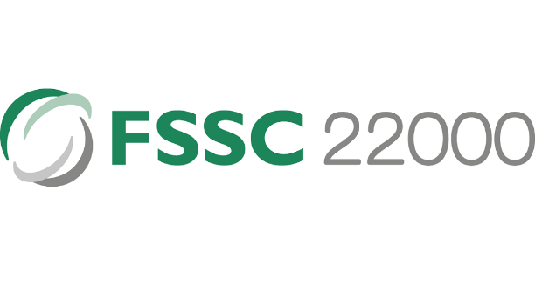

* HALAL Certified Suppliers: Merry Meals can partner with suppliers who have obtained HALAL certification. This certification ensures that the ingredients used in the food production process comply with halal regulations, catering to the dietary needs and preferences of customers who follow halal guidelines.



* + 1. **Project**
* Merry Meals Website Maintenance: The company plans to conduct ongoing maintenance for the Merry Meals website. This maintenance will ensure the website remains functional, up-to-date, and optimized for a seamless user experience.
* SSL Certification: Merry Meals aims to obtain SSL certification for their website. This certification guarantees secure communication between the website and its users by encrypting data transmitted over the internet. It enhances data protection and builds trust among users.
* Daily Backups: Merry Meals will implement a daily backup system for their website. This process will ensure that all website data and information are regularly backed up within a timeframe of 10 hours. It provides an additional layer of data protection and facilitates quick recovery in case of any unforeseen issues or data loss.
* One-Month Range of Work: The project is estimated to be one month, encompassing various stages such as development, testing, and implementation. The timeline allows for adequate planning, resource allocation, and progress monitoring throughout the project.
* Developer-Conducted Testing: The project’s testing phase will be conducted by the developer responsible for the Merry Meals website. This includes thorough testing of different functionalities, user interactions, and performance to ensure that the website meets quality standards and functions as intended.
  1. **Project Constraint**

Project constraints refer to the limitations or risks that arise due to limited resources or external requirements. These constraints can be internal, such as budget constraints or skill limitations, or external, such as regulatory requirements or market conditions. Understanding project constraints is crucial for identifying risks and taking appropriate measures to manage them in order to achieve project success.

**FSSAI FOOD LICENSE**

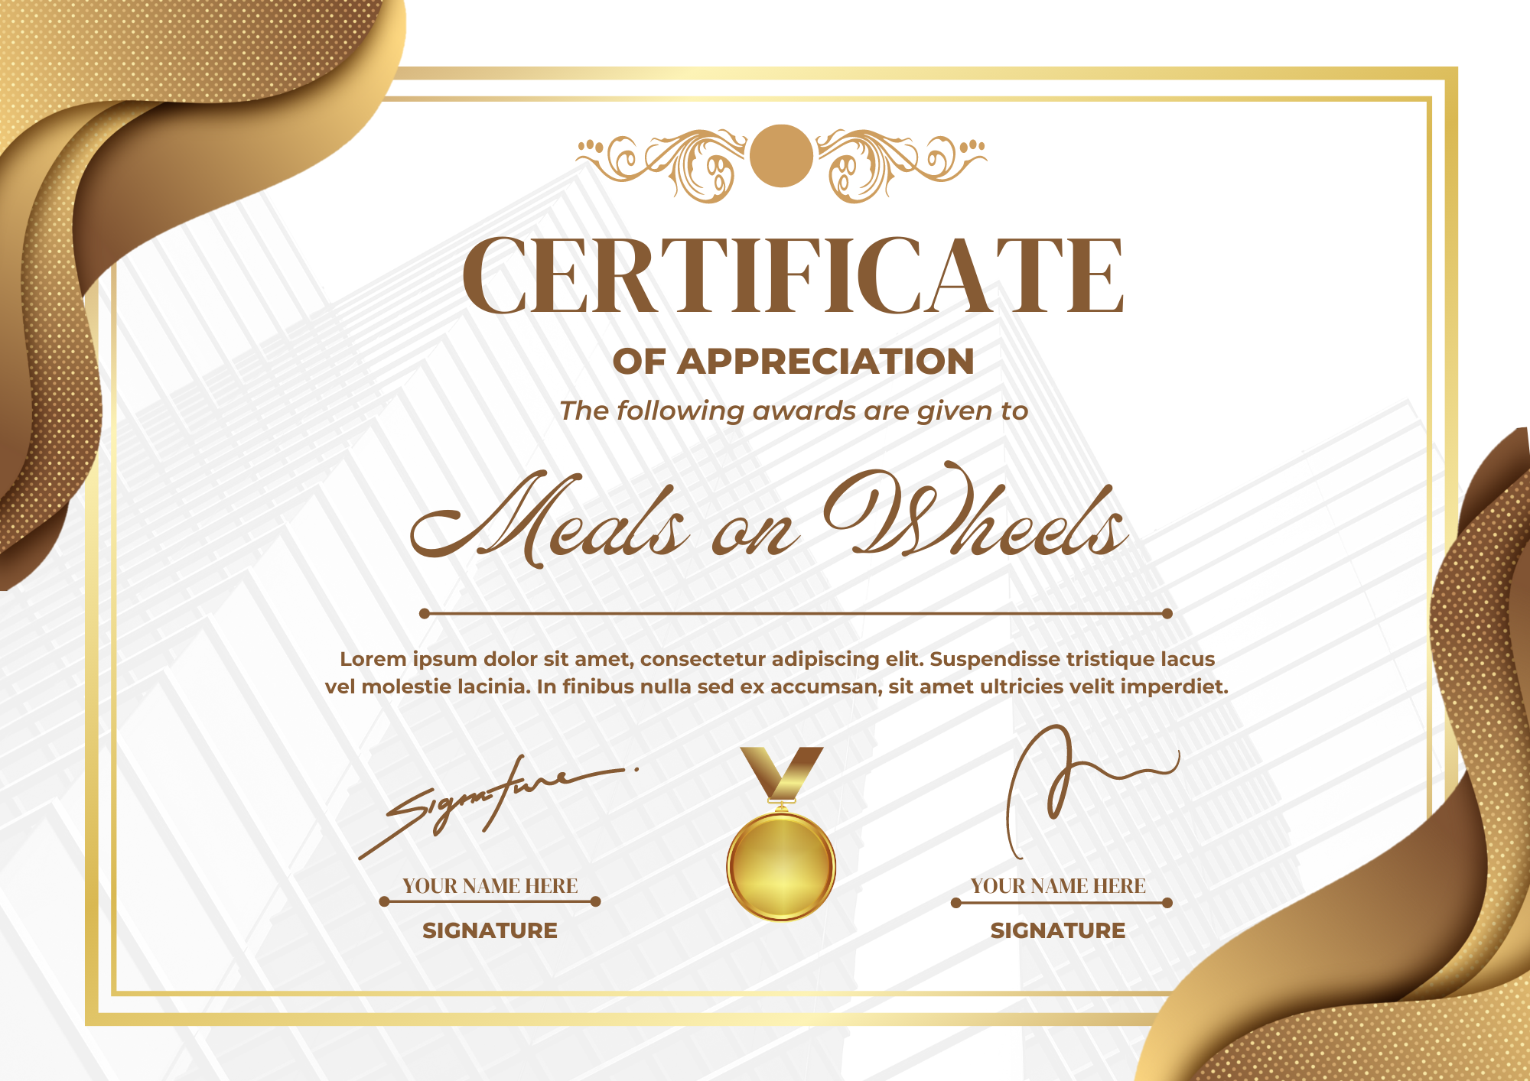

( Figure 1 : FSSAI FOOD LICENSE )

* + 1. **Client**
* Delivery Radius for Hot Meals: Hot meals can only be delivered within a 10 KM radius. This constraint sets a maximum distance for the delivery of hot meals.
* Frost meals can be delivered above a radius 10 KM.

Delivery Radius for Frost Meals: Frost meals can be delivered beyond a 10 KM radius. This constraint establishes a minimum distance for the delivery of frost meals.

* Service Availability Constraint: The delivery service is available daily except for Saturdays and Sundays. This constraint restricts the availability of the service to specific days of the week, potentially affecting delivery schedules and customer expectations.
* Different ages of customers will be considered in developing the Merry on Wheels website to avoid misleading or misunderstanding.
  + 1. **Time**
* The Merry on Wheels website development must be completed within a timeframe of 1 month. This constraint sets a limited time for designing, developing, and launching the website.
  + 1. **Scope**
* Inability to Complete Project Scope in Case of Budget Increase: The previously defined project scope for Merry on Wheels cannot be accomplished if there is a budget increase or costs exceed the initial calculations. This constraint emphasizes that if there is a significant cost increase, certain parts of the project scope may need to be reduced or re-evaluated to maintain a balance between cost and scope.
  + 1. **Cost**
* Cost constraint in a project refers to the limitation on the project budget. It involves managing and controlling project expenses to ensure that the project is completed within the approved budget. Adhering to the cost constraint is crucial for project success and requires careful budget planning, estimation, and monitoring to prevent cost overruns. The project can achieve its desired outcomes by optimizing the use of available resources and maintaining financial feasibility while staying within the defined cost boundaries.
  + 1. **Resources**
* Limitations of Software, Technology, and Hardware: The Merry Meals project faces constraints in terms of software, technology, hardware, and other required resources. This constraint implies that the available resources for the project are limited, whether in terms of quantity, quality, or technological capabilities.
  + 1. **Environment**
* Comfortable Working Conditions for the Development Team: The development team requires a comfortable and supportive working environment to carry out their tasks. This constraint emphasizes the importance of providing adequate facilities and a suitable working environment for the team to work effectively and efficiently.
* Fast Communication Among Team Members and Clients or Other Stakeholders: Team members must communicate quickly and effectively with clients or other relevant parties. This constraint highlights the importance of having an efficient and reliable communication system to ensure smooth information exchange between the team and stakeholders.
  + 1. **Skill**
* The Personnel Skill in Java: Personnel with skills in the Java programming language must meet the project's skill requirements. This constraint emphasizes the importance of ensuring that assigned personnel have the knowledge and skills required for development using the Java programming language.
  + 1. **Man Power**
* Team Proficient Team Members in Java: Team members must possess proficiency in the Java programming language. This constraint emphasizes the importance of team members with a strong understanding and skillset in the Java programming language.
  1. **Project Milestone: Progress to measure to achieve goals** 
     1. **Requirement gathering**

The Merry Meal project manager will speak with Merry Meal's employees and stakeholders to find out what they envision. The Merry Meal Project must be able to provide free food services to people in need, such as older people or people with disabilities. They can order the food through a website. Then later, there will be several menus on the website that we can choose from with the applicable terms and conditions. To be able to order on the website, the person must first register on the website as a member. After registering, the member can choose the food on the menu list. The admin sends a message to the Partners to prepare hot food if it is under ten kilometers. The partner will prepare cold food if the distance is more than ten kilometers. After that, the admin will choose an available driver to send the food. After that, the driver will pick up the food and send the food to the member. On the website, people can donate their money, people can participate in these activities as volunteers, and choose to be caregivers or drivers. The website must be secure so that it cannot be hacked by hackers and maintain the data security of members, caregivers, partners, volunteers -the website must be secured so that it cannot be hacked by hackers and maintain the data security of members, caregivers, partners, volunteers must be packed safely - food is labeled haram and halal.

* + 1. **Validate expectations for requirements**

Informed of the requirements after the project manager has compiled all of the requested requirements and listed them in a document. Informed of the requirements after the project manager had compiled all the requested needs and listed them in a document.

* + Members and Caregivers registration with their requirements.
  + Partners and Volunteers registration with their details.
  + Fundraising through Donors / Supporters.
  + Menu Planning and Preparation.
  + Meal Delivery Management of partners and riders.
  + Verified that admins can message partners to prepare hot meals if they are less than ten kilometers away, and partners will prepare cold meals if they are more than ten kilometers away.
  + Food is labeled haram and halal.
  + Food Safety Management.
  + website security and data for all users.
  + Reassessment of need evaluation.
  + Management Information System for effective management
    1. **Predevelopment planning**

The project manager will assign each team member their task and duties once the requirements and development plan have been finalized.

|  |  |
| --- | --- |
| Team Member | Task |
| Agung Yuda P. | Manage the Administrator's functions. |
| Muhammad Kemal | Manage the Partner’s functionality |
| M. Reihan Z.A | Manage the Member and Donor functionalities. |
| Rafael Richie S.U | Manage the Caregivers functionality |
| Rocky Ramdhan Setiawan | Manage the Volunteer’s functions. |

* + 1. **Implementation**

The implementation phase marks the beginning of the project's development, building upon the groundwork laid during the predevelopment stage. During this phase, the following activities will be carried out:

* + - 1. Creating a web-based application: The development team will build the web application based on the identified requirements and design specifications. This involves designing and implementing the user interface, system functionalities, and database components necessary to support the application's features.
      2. Registration functions: The implementation will include the development of registration functionalities for various stakeholders, such as members, partners, caregivers, and volunteers. This will enable them to create accounts and provide the required information to participate in the Meals on Wheels program effectively.
      3. Donation processing: The implementation will integrate donation processing features. This functionality will enable donors and supporters to contribute funds to the Merry Meals organization through a secure and user-friendly platform.
      4. Food menu lists: The implementation phase will involve creating a menu planning and preparation system. This functionality will allow the organization to manage and update the menu options available to members, ensuring a diverse and nutritious meal selection.
      5. Food delivery safety: The implementation will include features and protocols to ensure food delivery safety. This may involve incorporating guidelines for handling, packaging, and transporting meals to maintain their quality and adhere to food safety standards.
      6. Management information systems: The implementation will encompass developing a management information system. This system will give the organization valuable insights and data on program performance, member needs reassessment, and overall operational effectiveness.
    1. **Quality Assurance testing**

Quality assurance testing plays a crucial role in ensuring the reliability and effectiveness of the developed product or system. After the implementation phase, the following activities will be carried out to ensure that the product aligns with the specified requirements:

1. Verification: involves a thorough inspection to determine whether the product or deliverables meet predetermined requirements. This includes reviewing functionality, design, and implementation against specified specifications.
2. Validation: The validation process focuses on ensuring that the product or deliverables meet the needs of the end users and align with the desired business objectives. It involves assessing user satisfaction, usability, and the overall alignment of the product with the intended purpose.
3. Functional Testing: Functional testing is performed to verify whether the system or application functions correctly based on the predetermined specifications. It involves executing test cases that cover all the functional requirements, ensuring that each component operates as intended.
4. Non-Functional Testing: Non-functional testing evaluates the system's non-functional aspects, including performance, security, reliability, and scalability. This testing ensures that the system can handle the expected workload, is secure against potential threats, operates reliably, and can accommodate future growth and increased usage.
5. Integration Testing: Integration testing focuses on testing the interactions between different system components or modules to ensure they are properly integrated. It verifies that data and control flow between the parts is seamless and that the integrated system functions as a cohesive unit.
   * 1. **User Acceptance testing**

User Acceptance Testing (UAT) is an essential phase in the project, conducted after completing Quality Assurance testing. During this phase, the individuals involved in the project can test the created website and provide valuable feedback to ensure its alignment with the desired goals and requirements. The primary objective of UAT is to determine whether the website meets the expectations and needs of its intended users.

The participants in the testing process will engage with the website, assessing its various functionalities and features. They will specifically focus on registration pages for members, partners, caregivers, and volunteers, evaluating whether they fulfill the specified requirements. Additionally, they will examine the effectiveness of the donation process and test the security system's functionality to ensure that it operates as intended.

Feedback from the participants will be gathered to identify any areas that require improvement or adjustment. This feedback may encompass usability, user experience, functionality, and any other relevant aspects of the website. By actively involving the project stakeholders and obtaining their feedback, the development team can address any issues or concerns, ensuring that the final product meets the expectations and requirements of the users.

User Acceptance Testing helps validate the website's usability and effectiveness from the end-users perspective. It provides an opportunity to identify gaps or shortcomings and make necessary enhancements before the website is officially launched. By incorporating user feedback, the project team can optimize the website's performance, functionality, and overall user experience, resulting in a final product that meets the expectations of all stakeholders..

* + 1. **Deployment**

The last step is to deploy the website so that it is open to the public when all the earlier processes have been finished and there are no more demands or jobs left undone.

The website is set up during deployment to go live on the chosen server or hosting platform. This includes adding the appropriate files, setting up the necessary options, and ensuring the website is operational and accessible.

To ensure that all features and capabilities are operating correctly in the live environment, conducting a last round of testing is advised before making the website accessible to the general public. This aids in locating any unforeseen problems or discrepancies that might have occurred throughout the deployment procedure.

The website can be officially published and made available to the intended users once the testing phase is through and every aspect is operating as intended. This entails typically tying the website's URL to the domain name so that users of web browsers may access and navigate the site.

Deployment signifies the culmination of the development process, as the website is now ready for users to interact with and fulfill its intended purpose. Monitoring the website's performance and addressing any user feedback or issues that may arise post-deployment is essential to ensure optimal functionality and user satisfaction.

By following a well-planned and executed deployment process, the website can be successfully launched, providing value and meeting the needs of its intended audience.

* + 1. **Support**

During the support phase, after website implementation, Merry Meal's development team will diligently provide ongoing support and maintenance. This includes monitoring the website for bugs and resolving them promptly to ensure smooth operation. They will perform routine maintenance activities, apply necessary updates and patches, and optimize performance. Users will be offered technical assistance, answering their questions and solving problems. Feedback from users will be collected and used for future improvements while staying updated with technological advances to ensure the website remains relevant and user-friendly. The support phase ensures website stability, functionality, and user satisfaction, providing lasting value to the Merry Meal organization and its users.

* 1. **Project deliverables** 
     1. **Internal deliverables**
* Web design proposal and software design document (SSD)
* Web design proposal: a thorough description of the online application for Meals on Wheels suggested design. The visual design, user interface components, and interaction design are all included.
* Software Design Document (SSD): A thorough document detailing the architecture, parts, and design of the Meals on Wheels web application It covers database designs, user interface designs, subsystem designs, and system requirements.
  + 1. **External deliverables**
* Finish Meals on Wheels web application

The website lets people place meal orders, sign up as members, give money, and volunteer their services. It has every feature and capability listed in the project requirements.

* + 1. **Planning deliverables**
* Project Scope

A document defining the boundaries and objectives of the Meals on Wheels project. It outlines the features, functionalities, and constraints of the web application.

* Budget

A financial plan detailing the estimated costs and resources required for developing and implementing the Meals on Wheels web application. It includes development, hosting, maintenance, and other project-related expenses.

* Project schedule

A timeline that outlines the key milestones, tasks, and dependencies for developing and delivering the Meals on Wheels web application. It provides a roadmap for the project's execution and helps track progress.

* 1. **Functional description (Group)**

|  |  |  |  |
| --- | --- | --- | --- |
| No | User type | Description | Roles based access |
| 1 | Member | Members are people who need help or support | * Register * Login * Order and view meals * Update profile * Track the Meals |
| 2 | Care giver/Drivers | Merry on Wheels support teams help the members | * Register * Login * See the status of the food made * Processing ordered meals in partners |
| 3 | Partners | Preparing the food | * Register for partnership * Login |
| 4 | Volunteers | Participate in Charity activities in Meals on Wheels. | * Register * Login * View Other member, update profile |
| 5 | Donator / supporter | A person who regularly makes donations in the form of money | * Register * Login * Donate |
| 6 | Administrator | Manage almost the entire running of the website | * Register * Login * Manage donation * Manage member * Manage menu / order * Manage driver * Manage information systems |

* 1. **Risk analysis and description**

Risk is the possibility of an event or condition occurring that may result in a negative impact or loss. Risk involves uncertainty, where the outcome or consequences of an event cannot be predicted with certainty.

* + 1. **Identify possible area of risk in the application development**

a) Data security: Risk of leakage or misuse of customer personal data, such as address, telephone number or financial information.

b) System integration: Risk of difficulty or failure in integrating the application with existing systems at MerryMeal or food service providers.

c) Reliance on third parties: Risk of dependence on third party service providers, such as delivery service providers, which may experience technical problems or service failures.

d) Application performance: Risk of slow or unresponsive application performance when used by users, especially when there is a spike in order traffic.

e) Scalability: The risk of the application being unable to handle the rapid increase in the number of users or orders, especially when entering a new market or when there is a significant increase in demand.

f) Functional errors: The risk of bugs or errors in application functions that may cause harm or inconvenience to the user.

* + - 1. **Internal risk**
* **Technology Risk**

Risks associated with hardware or software failures used in application development, such as server failures, security vulnerabilities, or compatibility issues.

* **Physical Risk**

Risks related to damage or loss of hardware or physical infrastructure used in the development or operation of applications, for example, damage due to natural disasters or criminal acts.

* **Human Factor Risk**

Risks associated with human error in the development, testing or operation of applications, such as programming errors, lack of expertise or unintentional actions that may result in loss or system failure.

* + - 1. **External Risk**
* **Political Risk**

Risks related to changes to government policies or regulations that may affect the operation of the application, for example, changes to data privacy regulations or food delivery regulations.

* **Natural Risk**

Risks associated with natural disasters, such as earthquakes, floods, or hurricanes, may disrupt the physical infrastructure or food delivery services, and may affect the availability or quality of food ingredients.

* **Economic risk**

Risks related to economic fluctuations or market conditions that may affect the sustainability of application operations, such as decreased purchasing power or unstable macroeconomic conditions.

* + 1. **Analyze and Evaluate**

|  |  |  |  |
| --- | --- | --- | --- |
| **No** | **Risk type** | **Risk description** | **Risk Impact** |
| **1** | Technological | Poor quality code and security while developing the app. When the quality and safety of a project does not meet stakeholder expectations, there is a significant risk that the project will fail. | Security flaws can result in data breaches, loss of customer information, leak of customer information or even loss of customer trust. This can damage the reputation of the organization and cause financial losses. |
| **2** | Human Factor | Lack of experience, knowledge, or human error in developing or operating the Meals On Wheels app. | Human error can result in data loss, system instability, or functional errors affecting user experience. This may result in additional costs being incurred to repair or resolve problems caused by the error. |
| **3** | Economic | Changes in market conditions may affect the funding and operational sustainability of the Meals On Wheels application. | An increase in purchases of raw materials due to increased market prices can result in financial difficulties and difficulties in keeping the application operational. |
| **4** | Physical | Damage or loss of hardware, infrastructure, or data centers used in developing or operating the Meals On Wheels application. | Hardware damage or loss can result in system crashes, data loss, or service interruption. This can lead to delays in food delivery, customer inconvenience, or decreased trust in the app. |
| **5** | Natural | Natural disasters such as earthquakes, floods, and hurricahat may disrupt physical infrastructure or food delivery services. | Natural disasters can cause damage to infrastructure, interruption of food delivery services, or decrease in the quality of food ingredients. This can result in delivery delays, inconvenience to customers, or even threaten the safety of drivers, volunteers, partners and even members. |
| **6** | Political | One of the team members' governments banned one of the software or platforms. | If any software or platform used during the development phase is banned, the developer must find an alternative to the banned application and adapt and learn it all over again. This would also cause a significant delay in the project's progress. |

* + 1. **Prepare Risk Matrix**

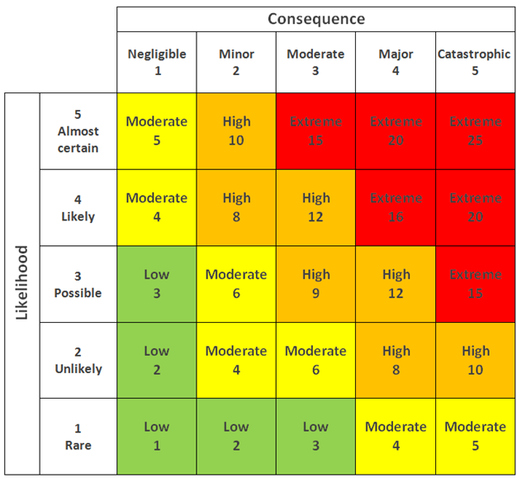

|  |  |  |  |  |  |  |
| --- | --- | --- | --- | --- | --- | --- |
| **No** | **Risk type** | **Risk description** | **Likelihood (1-5)** | **Consequence (1-5)** | **Risk rating** | **Risk level** |
| 1 | Technological | Poor quality code when developing applications. When a project's quality does not meet stakeholder expectations, there is a significant risk of failure. Poor quality code can occur for various reasons, including project underestimation and developers rushing to complete iterations. | 4 | 5 | 20 | Extreme |
| 2 | Physical | Risks related to damage or loss of hardware, infrastructure or data centers used in the development or operation of the Meals On Wheels application | 3 | 4 | 12 | High |
| 3 | Human Factor | Risks related to human error in the development, testing or operation of Meals On Wheels applications, such as programming errors, team communication failures or user errors. | 4 | 3 | 12 | High |
| 4 | Economic | Changes in market conditions may affect the funding and operational sustainability of the Meals On Wheels application. | 3 | 3 | 9 | High |
| 5 | Natural | Natural disasters such as earthquakes, floods, hurricanes that can disrupt physical infrastructure, food delivery services and even cause casualties. | 1 | 5 | 5 | Moderate |
| 6 | Political | One of the team members' governments banned one of the software or platforms. | 1 | 3 | 3 | Low |

* + 1. Risk Response Analysis

|  |  |  |  |
| --- | --- | --- | --- |
| **No** | **Risk type** | **Risk description** | **Risk Response Plan** |
| **1** | Technological | Technology risks related to technology system failures or vulnerabilities used in Meals On Wheels application development, such as security vulnerabilities, hardware failures, or compatibility issues | Adopt strict security practices and regularly monitor systems to reduce the risk of technology failure or vulnerabilities. |
| **2** | Human Factor | Risks related to human error in the development, testing or operation of Meals On Wheels applications, such as programming errors, team communication failures or user errors. | Provide proper training to the development team and implement rigorous testing procedures to reduce the risk of human error. |
| **3** | Economic | Changes in market conditions that may affect the funding and operational sustainability of the Meals On Wheels application. | Building a flexible financial strategy and forging more partnerships with food providers to address economic risks. |
| **4** | Physical | Risks related to damage or loss of hardware, infrastructure or data centers used in the development or operation of the Meals On Wheels application | Secure physical safeguards such as property insurance and fire suppression systems, and perform regular data backups to reduce the risk of physical damage and data loss. |
| **5** | Natural | natural disaster come that caused a lots damage to the workstation and perhaps loose many human resources. | Create a safe physical workspace for team members to prevent minor disaster yet further to major disaster. Apply job insurance to sateholder’s contract |
| **6** | Political | One of the team members' governments banned one of the software or platforms. | To address a government ban, there are several steps we can take. First, evaluate the reasons behind the ban to understand why it was imposed. It's also a good idea to consult a legal expert to get advice on the best action. We can consider appealing the ban or finding ways to improve compliance with the regulations. Establishing communication with the relevant government authorities is crucial to address concerns and find possible solutions. Lastly, explore alternative options or partnerships that comply with the regulations. |

1. **Project Team (Group)**
   1. **Team’s Member Information**

|  |  |  |  |
| --- | --- | --- | --- |
| **Partner** | **Learner ID** | **Full Name** | **Group ID** |
| STTB | BDSE-0922-076 | AGUNG YUDA PRATAMA | G04 |
| STTB | BDSE-0922-082 | MOHAMMAD REIHAN ZAKYA ALAWI | G04 |
| STTB | BDSE-0922-084 | MUHAMMAD KEMAL | G04 |
| STTB | BDSE-0922-086 | ROCKY RAMDHAN SETIAWAN | G04 |
| UNPJ | BDSE-0922-031 | RAFAEL RICHIE SOAUDON UDJULAWA | G04 |

* 1. **Team’s Member Role and Responsibilities**

|  |  |  |
| --- | --- | --- |
| **Name** | **Module** | **Details Tasks** |
| AGUNG YUDA PRATAMA | Manage the Administrator's functions. | * Develop a login system with role-based access control, allowing only authorized administrators to access the system. * Create a management interface for administrators to manage donations, including viewing and managing donations. * Implement member management functions, enabling administrators to manage member information, registration, and profiles. * Develop menu/order management functions, enabling administrators to create, modify, and delete food choices. * Implement driver management functionality, enabling administrators to assign drivers or riders to delivery tasks. * Create an information system management interface for administrators to manage the entire system effectively. |
| MOHAMMAD REIHAN ZAKYA ALAWI | Manage the Member and Donor functionalities. | * Develop member registration functionality, allowing eligible adults to register as members. * Implement a secure login system for members to access their accounts. * Create views for members to order and view food based on their needs. * Implement the ability for members to update their profiles and track their food delivery. * Develop donation functionality, allowing individuals or organizations to register as donors/supporters. * Implement a login system for donors to access their accounts securely. * Create a view for donors to edit their profiles and send donations to support Meals on Wheels activities. |
| MUHAMMAD KEMAL | Manage the Partners functionality | * Implemented partner registration function, enabling individuals or organizations to register as partners. * Develop a login system for partners to access their accounts securely. * Create a view for partners to view food that has been ordered. * Implement processes to process ordered food according to Meals on Wheels specifications. |
| ROCKY RAMDHAN SETIAWAN | Manage the Volunteers functionality | * Develop volunteer registration functionality, allowing individuals to register as volunteers. * Implement a login system for volunteers to access their accounts securely. * Grant access to their respective roles based on the role they selected during registration (caregiver or rider). * Create a view for volunteer drivers to see their assigned food delivery schedules. * Implement the ability to volunteer as a driver to update delivery status (pick-up, en route, completed). * Develop edit or view profile pages for volunteers to manage their personal information. * Apply the skills of volunteers with kitchens to process ordered food according to Meals on Wheels specifications. |
| RAFAEL RICHIE SOAUDON UDJULAWA | Manage the Caregivers(Rider) functionality | * Implement driver registration functionality, enabling individuals to register as drivers for Meals on Wheels food delivery. * Develop a secure login system for drivers to access their accounts. * Create a view for drivers to see food delivery schedules and set pickup locations. * Implement the ability for drivers to update delivery status (e.g., picked up, on the way, done) for each food delivery. * Integrate a notification system to notify drivers of new delivery assignments or changes to existing deliveries. * Implement features for drivers to view and manage their profile information, including updating contact details or vehicle information. |

* 1. **Schedule**

Below is the schedule table for working on Meals on Wheels project from June 15, 2023, to July 7, 2023:

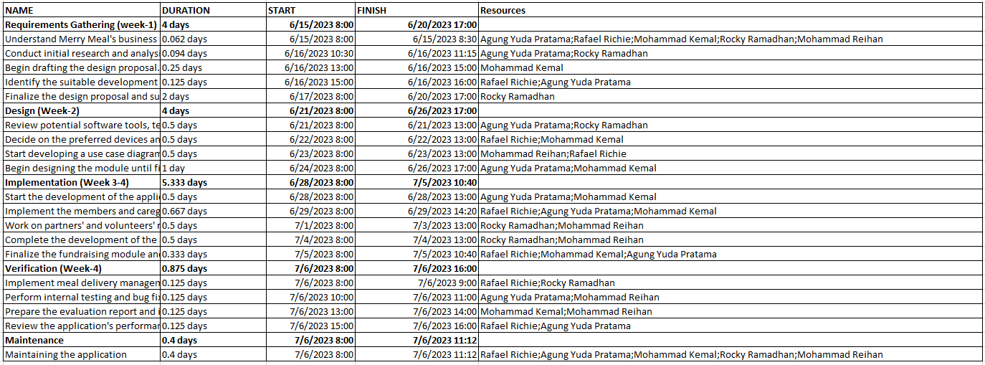

* 1. **Gantt Chat**

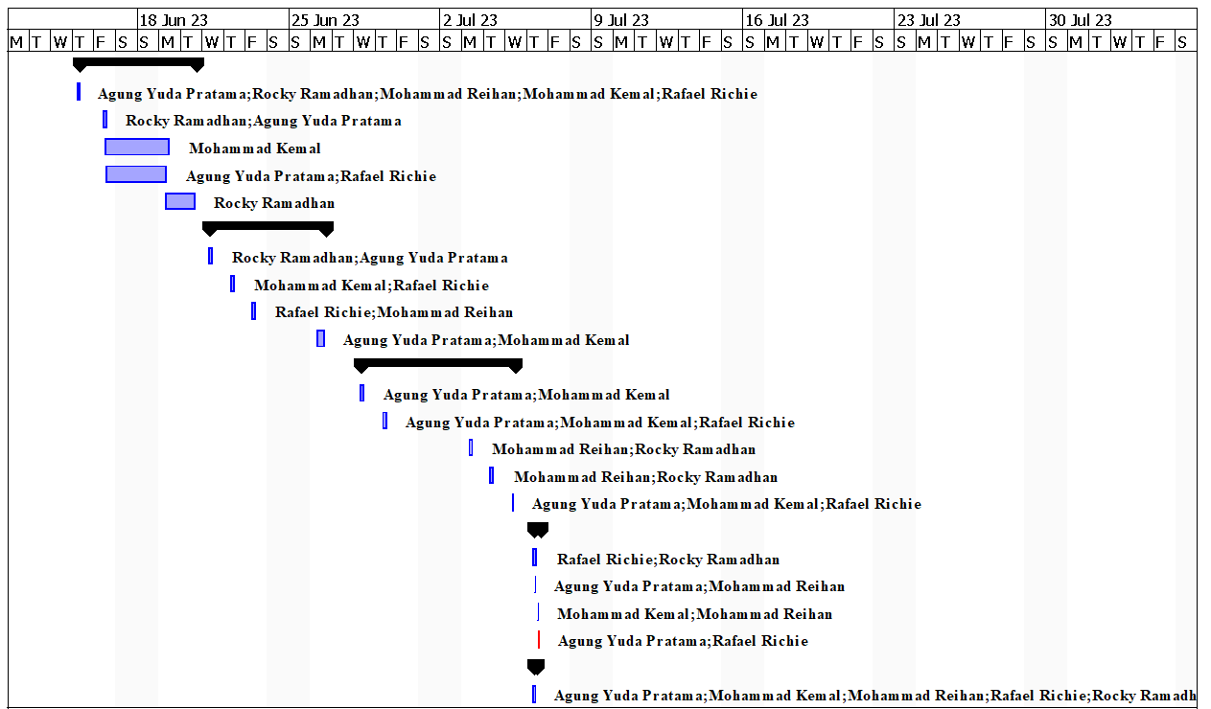

A Gantt chart is a visual project management tool that illustrates the schedule and progress of tasks or activities over time. It consists of horizontal bars representing individual tasks arranged along a timeline. Each bar's length corresponds to the task's duration, and their placement shows the start and end dates. Gantt charts help project managers and teams track and plan activities, identify dependencies, allocate resources, and monitor project progress. Gantt charts offer a structured and visual approach to project management, facilitating planning, monitoring, and coordination, leading to improved project efficiency and success.

1. **Detailed Plan – at the features level**

I will concentrate on creating the system's administrator capabilities based on the task we separated before. To guarantee that only authorized administrators can access the system, my project plan calls for developing a login system with role-based access control. I'll place a management interface to view and handle donations properly. I will also create member management features to manage member data, registrations, and profiles. I'll also work on the feature that lets me add, edit, and remove meal items from the menu and manage orders. To assign drivers or riders to delivery assignments, I will build driver management capabilities for delivery tasks. Furthermore, I will create an information system management interface that will provide me with the tools to manage the overall system effectively. With this project, I aim to have a robust and user-friendly design that allows me to efficiently handle donation management, member management, menu and order management, driver management, and overall system management.

1. **UML/Flowchart/**pseudocode/storyboards (Individual)
   1. **UML ( Use Case Diagram )  
      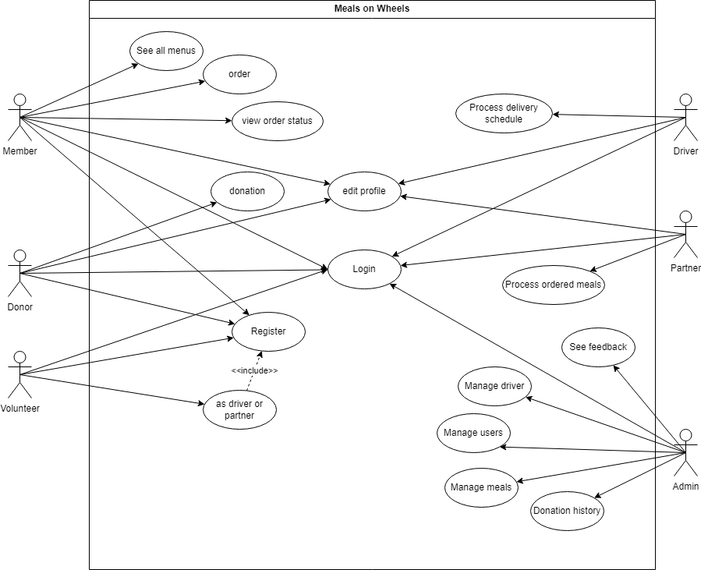**
   2. **Storyboard**

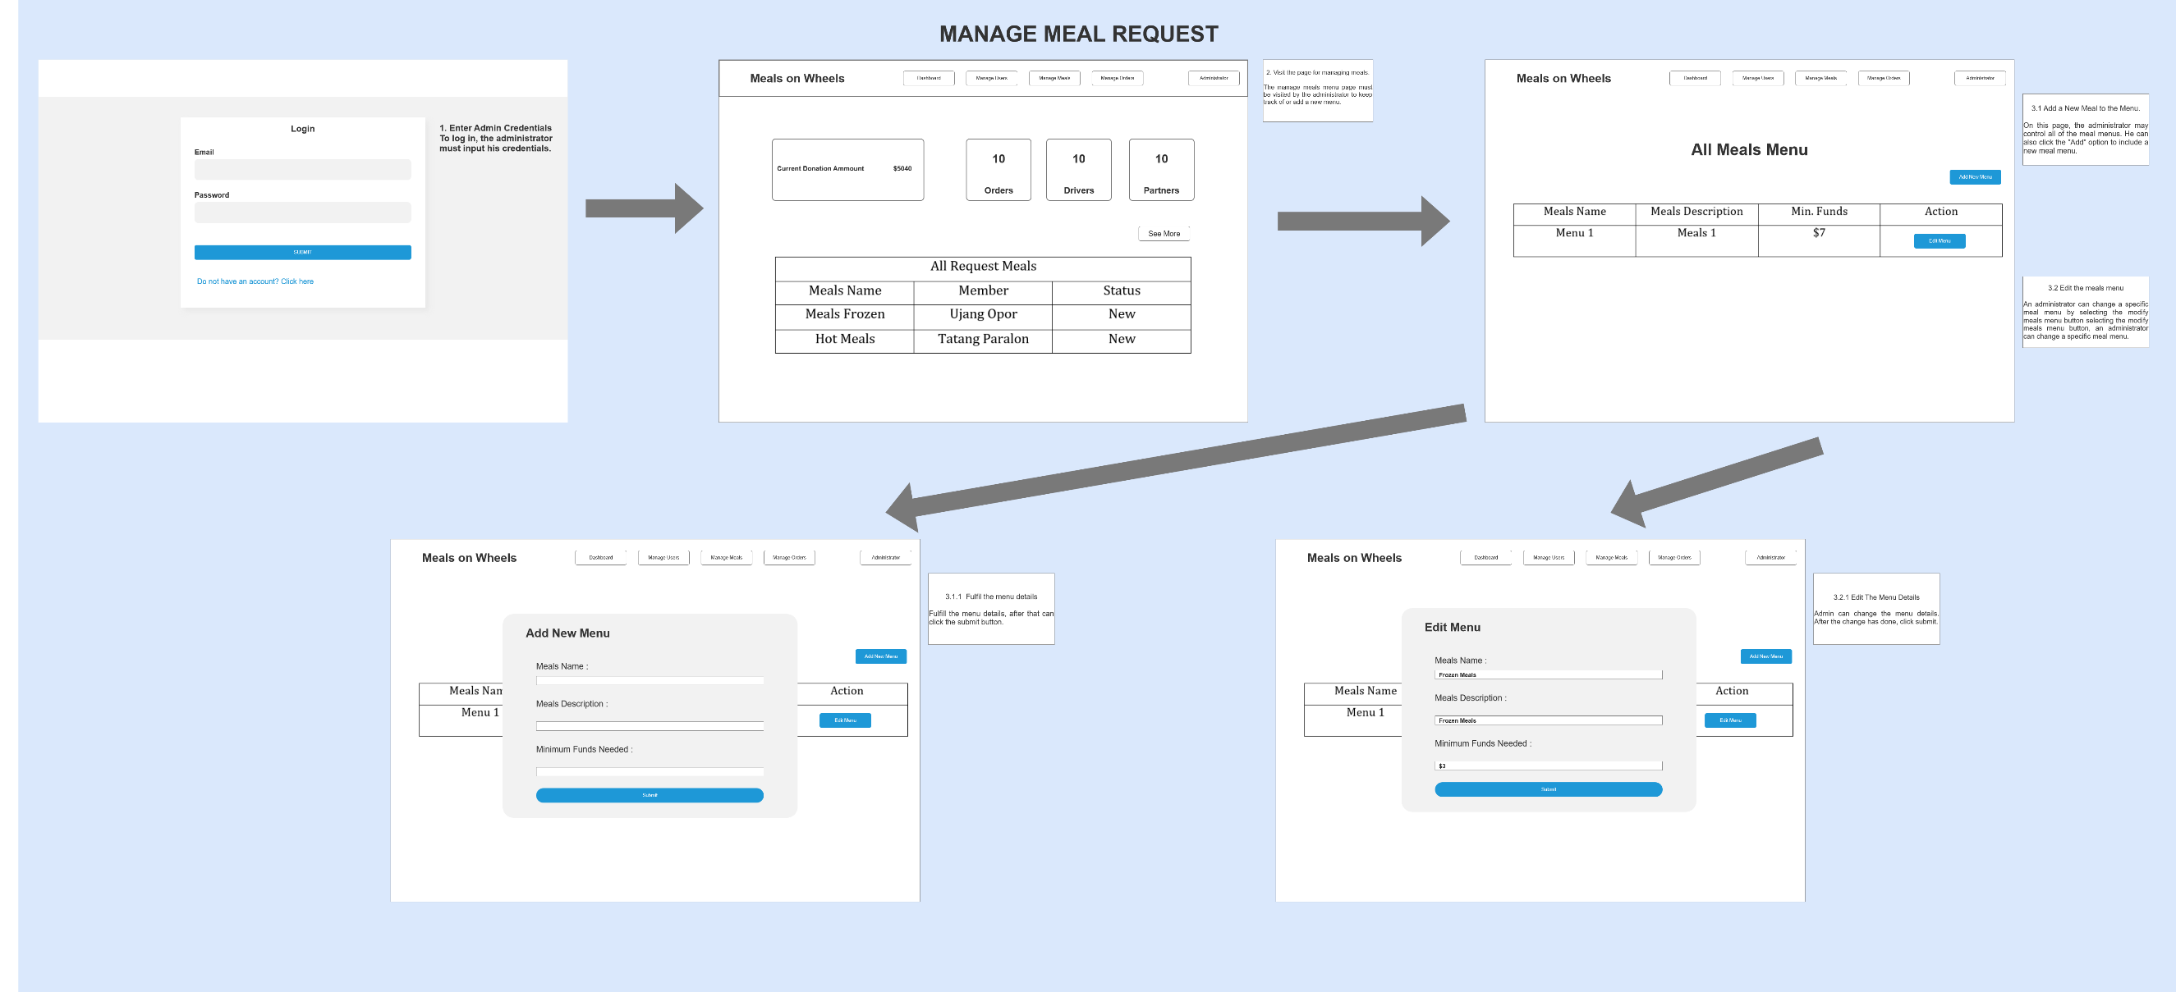

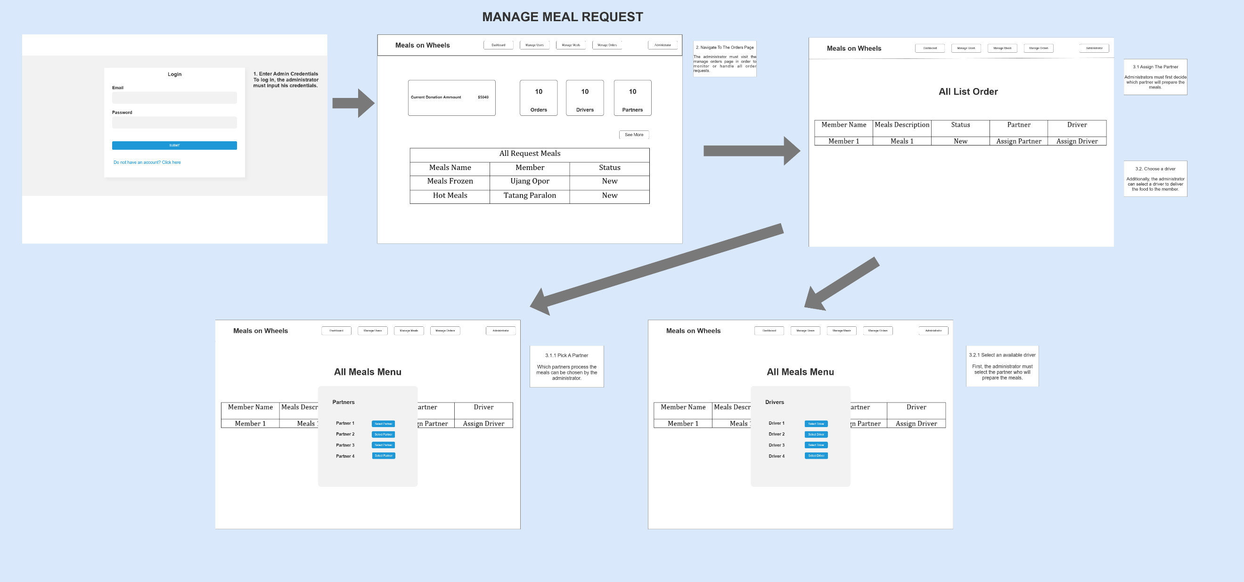

* 1. **Flowchart**
     1. **Admin Flowchart**
        1. **Admin Login**

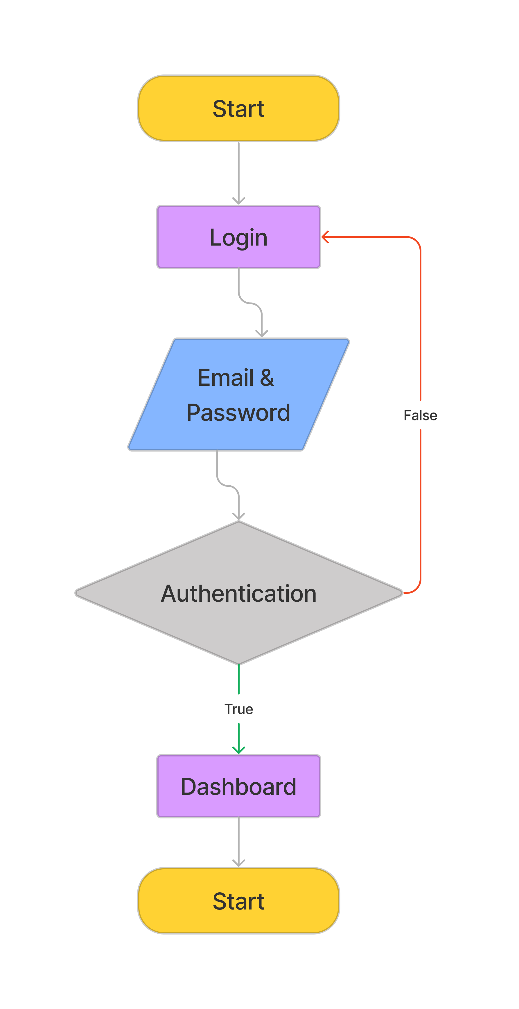

* + - 1. **Admin Manage Order**

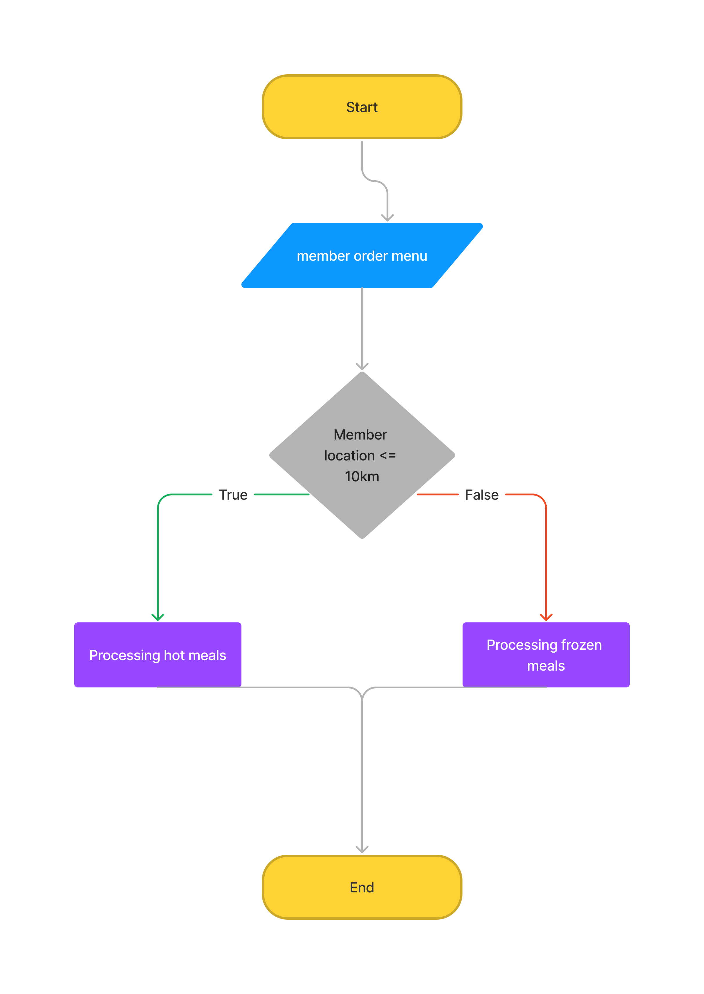

* + - 1. **Admin CRUD Manage user, driver and meals**

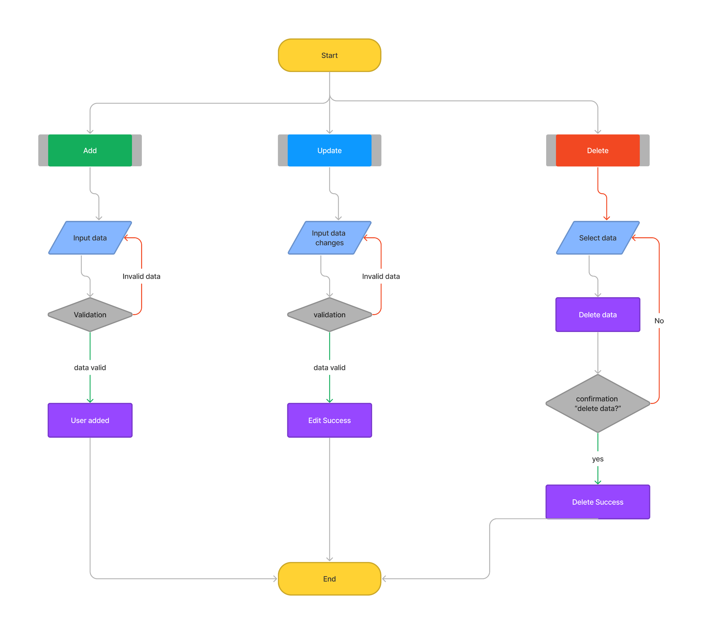

* + - 1. **Admin feedback & donation history**

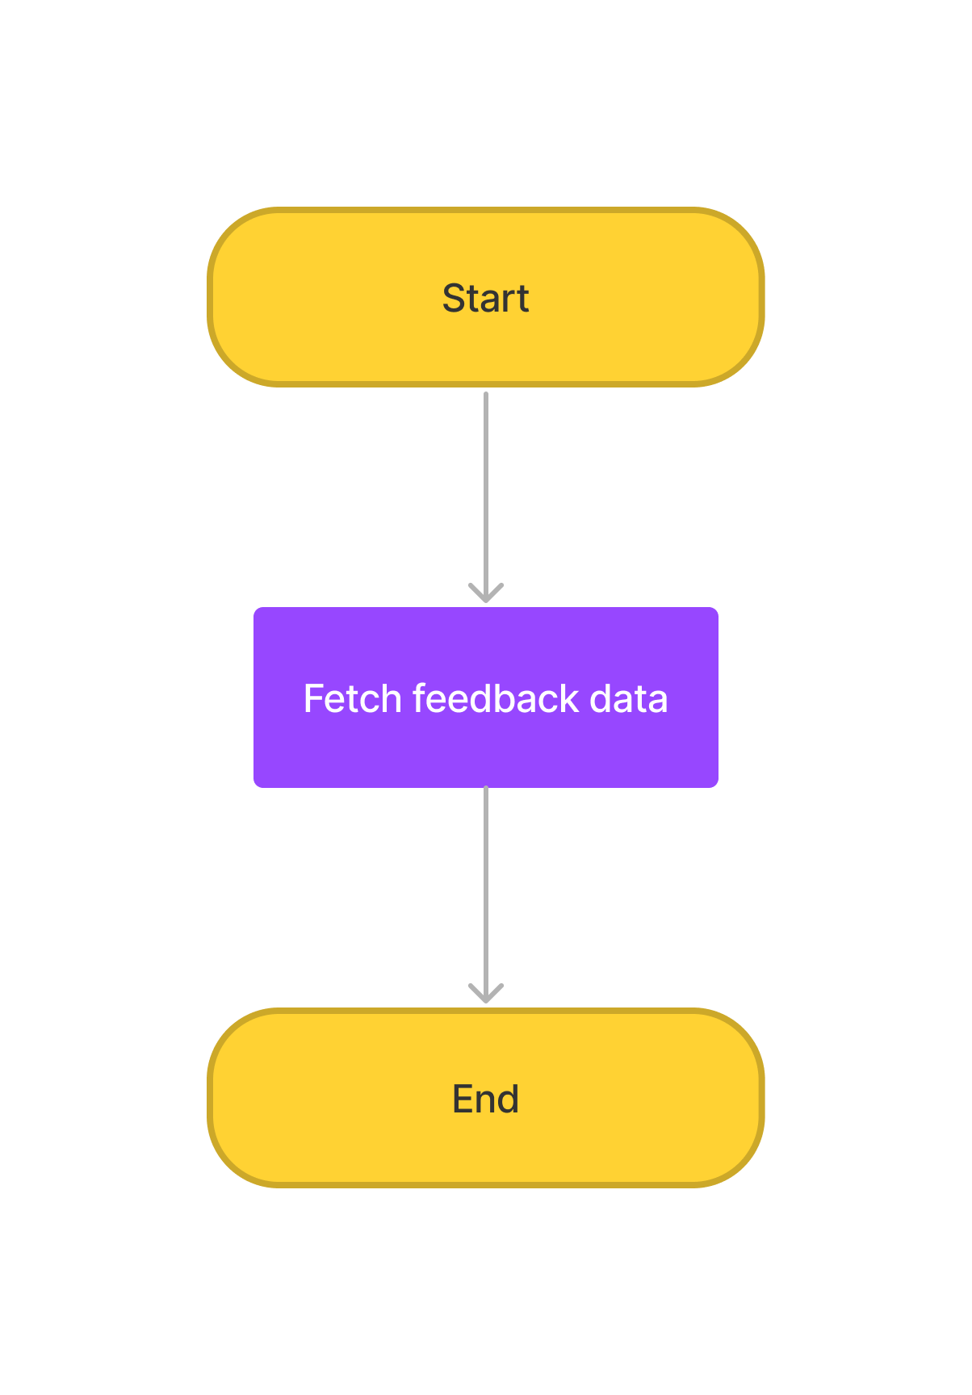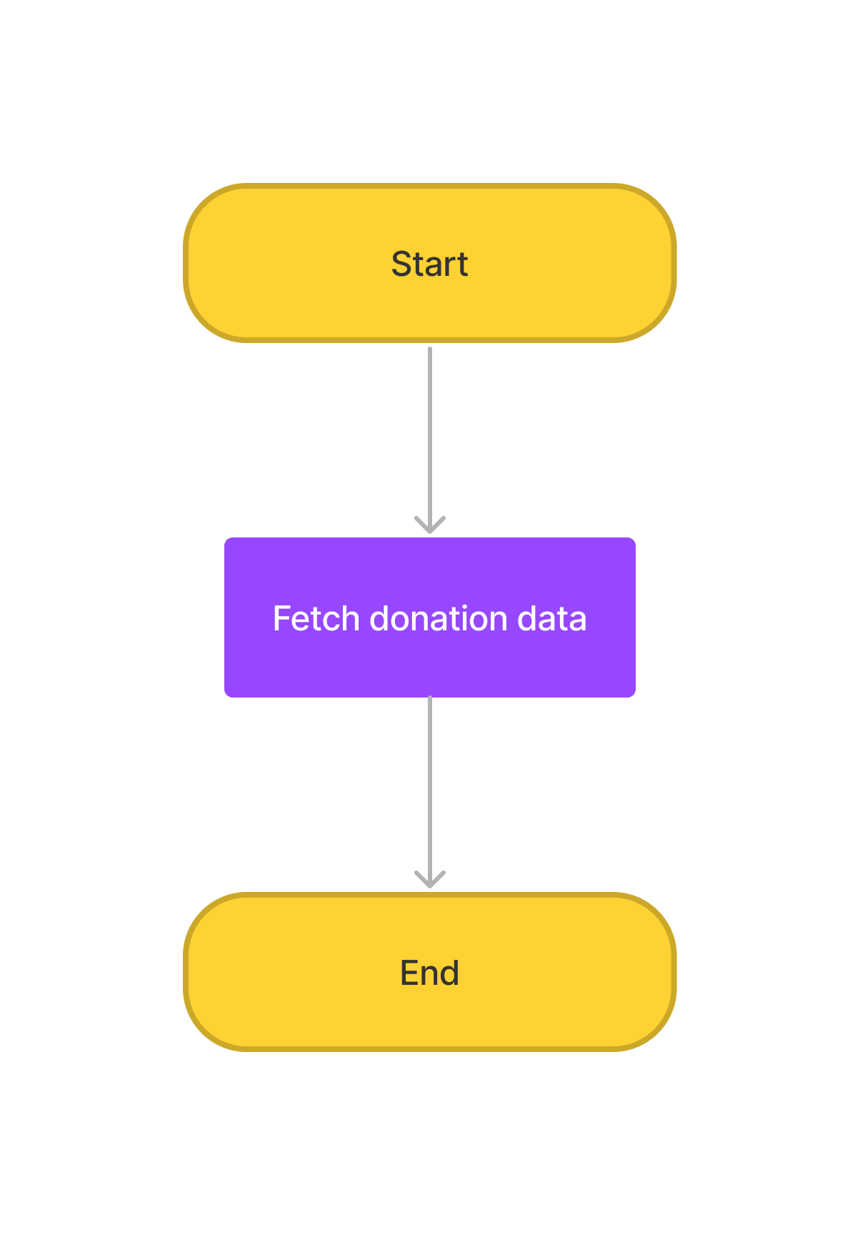

1. **Project Test Planning** 
   1. Food Safety Management Test Plan

To assess our project's effectiveness and ensure it complies with the necessary standards, we will do several tests. The testing method consists of unit tests to examine individual components, user acceptance tests to gauge user pleasure, performance tests to gauge system performance, and compatibility tests to guarantee the program functions without a hitch across a range of platforms and devices. We can validate the project's functionality, usability, and general quality with the aid of these tests.

* + 1. The testing plan for the Meals on Wheels portal includes the following testing

1. Functional Testing - UAT test cases - 5 atleast
2. Compatibility - Cross-browser testing / responsiveness
3. Performance Efficiency - Load Testing/ Stress testing
4. Portability - Multi platforms (different platforms, different devices)
   * 1. Test Plan Table
5. Test Scenario
6. Test Cases (Under one scenario, there may be more than one test cases)
7. Test Objectives
8. Expected Outcome
9. Risk
10. Techniques (Types of testing)

|  |  |  |  |  |  |  |  |
| --- | --- | --- | --- | --- | --- | --- | --- |
| Risk Id | Test Scenario ID | Test Scenario | Test Objective | Test Priority | Risk | Technique | Expected Result |
| 1 | TS001 | Validating login as an admin funtionality | To check admin credentials are existing in the system | High | Admin is not able to log in to the portal | Unit Testing | After checking, junit should return a passing result as admin data exist/present in the system |
| 2 | TS002 | Ensure meal’s menu can be added / save | To test adding a meal’s menu functionality | High | Admin not able to add a meal’s menu | Unit Testing | After checking, junit should return a passing result as meal’s menu data can be saved |
| 3 | TS003 | Ensure the functionality of send the requested meals to the partner’s kitchen | To test sending the requested meals to the partner worked properly | High | Admin not able to send the requested meals to the partner | Unit Testing | After checking, junit should return a passing result as meal’s data and partner that admin choose can be saved |
| 4 | TS004 | Ensure the functionality of send the delivery schedule to the driver driver | To test sending the delivery schedule to the driver worked properly | High | Admin not able to send the delivery schedule to the driver | Unit Testing | After checking, junit should return a passing result as meal’s data, delivery schedule, and driver that admin choose can be saved |
| 5 | UA001 | Ensure Admin can login in the portal | To allow admin to login with their credentials | High | Admin is not able to Login in the portal | UAT Testing | After login, admin will reach to the dashboard / private page |
| 6 | UA002 | Ensure admin can add meal’s menu in the portal | To allow admin to add a meal’s menu in the portal | High | Admin not able to add a meal’s menu in the portal | UAT Testing | Admin can add meal’s menu in the portal |
| 7 | UA003 | Ensure admin can send the requested meals to the partner’s kitchen | To allow admin to send the requested meals to the partner’s kitchen | High | Admin not able to send the requested meals to the partner in the portal | UAT Testing | After choosing the partner admin can send the requested meal’s to them |
| 8 | UA004 | Ensure if admin can send the delivery schedule to the driver | To allow admin to send the delivery schedule to the driver | High | Admin not able to send the requested meals to the partner in the portal | UAT Testing | After choosing the driver admin can send the delivery schedule to them |
| 9 | PM001 | Testing the performance of admin’s dashboard page | To utilize the page’s loading speed of the admin’s dashboard page using Chrome DevTools | Extreme | Admin will have a difficulty for managing the application process properly | Performance Testing | After testing, The loading time speed should be above 80 – 90% or less than 1s. |
| 10 | CB001 | Ensure Login page maintain a consistent look and feel in different browser (Chrome, Edge, Firefox) | To check a consistent look and feel of the login pageacross different browser | High | The admin may feel confused with the different look and feel in the login page so admin may have a difficulty for logging in to the portal | Compatibility Testing | After testing, Login page maintain a consistent look and feel across different browser |
| 11 | CB002 | Ensure manage users page maintain a consistent look and feel in different browser (Chrome, Edge, Firefox) | To check a consistent look and feel of the manage user’s page across different browser | High | The admin may feel confused with the different look and feel in the manage users page so admin may have a difficulty managing all the users in the portal | Compatibility Testing | After testing, manage users page maintain a consistent look and feel across different browser |
| 12 | CB003 | Ensure Admin’s dashboard page maintain a consistent look and feel in different browser (Chrome, Edge, Firefox) | To check a consistent look and feel of the admin’s dashboard page across different browser | High | The admin may feel confused with the different look and feel in the dashboard page so admin may have a difficulty tracking the order in the portal | Compatibility Testing | After testing, dashboard page maintain a consistent look and feel across different browser |
| 13 | PB001 | Ensure dashboard page maintain a consistent look and feel in different devices (laptop, iPad, phone) | To ensure all feature in the dashboard page is visible to the admin in different devices | High | Admin may feel difficulty to chose a different option as the website are not able to adapt to their device of choice | Portability Testing | After testing, all dashboard page is visible to the admin in different devices (laptop, iPad and phones) |